Project Report:
Analysis of Orbital Satellite Data for predicting decay days for space debris
Name : Abhinav Singh
Reg no: 12207257

Abstract:
This project presents a comprehensive analysis of a satellite orbital parameter dataset (`space_decay.csv`) comprising 14,372 space objects with 40 distinct orbital and metadata features. The research establishes an end-to-end analytical framework that progresses from foundational data preparation to advanced machine learning deployment, addressing critical challenges in space situational awareness and orbital debris management.
The initial phase focused on rigorous data quality assessment and validation, implementing automated pipelines for data profiling that identified and quantified data integrity issues including missing values, outliers, and redundant features. Through systematic outlier treatment using 95th percentile capping methodology, the project mitigated skewness in key orbital parameters such as PERIOD, SEMIMAJOR_AXIS, and ECCENTRICITY, ensuring robust statistical analysis. The elimination of ten non-informative features with zero variance streamlined the dataset while preserving analytical integrity
A significant innovation in this research was the creation of a novel `SPACE_ERA` feature, which categorizes satellites into historically significant periods based on launch dates: Early Space Age (1957-1969), Cold War Space (1970-1989), Commercial Space (1990-1999), Modern Space (2000-2009), and New Space Era (2010-Present). This domain-specific feature engineering captures the technological evolution and geopolitical context of space activities, providing crucial temporal context for trend analysis.
Exploratory Data Analysis (EDA) revealed transformative insights into space population dynamics, most notably documenting the massive proliferation of satellites in the modern "New Space Era." The analysis quantified an exponential growth pattern, with contemporary launch rates orders of magnitude higher than previous eras, directly attributable to the emergence of commercial mega-constellations and reduced launch costs. This finding highlights a paradigm shift in space activity from government-dominated programs to commercially-driven orbital infrastructure development.

Beyond exploratory analysis, the project advanced to predictive modeling by engineering a target variable for orbital decay prediction. The implementation of a comparative machine learning framework evaluated multiple algorithms including Random Forest, Gradient Boosting, XGBoost, and linear models. The Random Forest regressor demonstrated exceptional performance, achieving an R² score of 0.9987 with mean absolute error of 4.44 days, establishing a robust predictive capability for orbital decay timelines.

The research culminated in the development and deployment of a production-ready web application using Streamlit framework, hosted on Hugging Face Spaces. This deployment makes advanced orbital decay predictions accessible to a broad user base, featuring interactive dashboards, real-time prediction interfaces, and comprehensive model performance visualizations. The application architecture incorporates professional software engineering practices including modular design, comprehensive testing suites, logging systems, and exception handling.

This comprehensive analysis provides the crucial foundational work and curated dataset necessary for advanced orbital modeling, while simultaneously delivering an operational tool for space debris prediction. The project demonstrates the effective integration of data science methodologies with domain expertise in orbital mechanics, contributing to both academic research and practical applications in space situational awareness and long-term orbital sustainability. The scalable architecture and reproducible pipelines established in this work serve as a template for future analyses in the rapidly evolving domain of space traffic management and debris mitigation.

Contents
Project Report: 1
Abstract: 1
Chapter 1: Introduction 6
1.1 Background 6
1.2 Motivation 6
1.3 Dataset Source and Description 6
Key Features Include: 6
More Details about dataset: 7
1.4 Objectives 11
Data Exploration and Quality Assessment 11
Data Cleaning and Preprocessing 11
Feature Engineering 12
Exploratory Data Analysis (EDA) 12
Advanced Data Analysis & Predictive Modeling Preparation 12
Insights and Recommendations 12
1.4 Problem Statement 12
1.5 Scope of the Study 13
1.7 Challenges and Limitations 13
1.8 Technological Relevance 13
1.9 Potential Extensions 14
Chapter 2: Literature Review and Methodology 14
2.1 Introduction 14
2.2 Literature Review 2.2.1 Satellite Monitoring and Space Situational Awareness 14
2.2.2 Satellite Decay Prediction 15
2.2.3MachineLearning in Satellite Data Analysis 15
2.2.4 Gaps in Literature 15
2.3 Methodology 2.3.1 Data Collection 15
2.3.2 Data Cleaning and Preprocessing 15
2.3.3 Feature Engineering 16
2.3.4 Exploratory Data Analysis (EDA) 16
2.3.4 Advanced Analysis and Future Work Preparation 16
2.3.5 Recommendations and Reporting 16
2.4 Workflow Diagram 17
2.4 Summary 17
Chapter 3: Results and Discussion 18
3.1 Data Quality Summary 18
3.2 Era Distribution Analysis 18
Chapter 4: System Implementation and Deployment 24
4.1 System Architecture 24
4.1.1 Complete Directory Structure 24
4.1.2 File Count Summary 25
4.1.3 Module Responsibilities 26
4.2 Methodology Implementation 26
4.2.1 Complete ML Pipeline 26
4.2.2 Technical Features 27
4.3 Model Performance Results 27
4.3.1 Comparative Model Analysis 27
4.3.2 Feature Importance Analysis 27
4.4 Web Application Development 28
4.4.1 Streamlit Interface Features 28
4.4.2 Prediction Results 28
4.4 Deployment Results 29
4.4.2 System Validation 29
4.5 Key Achievements 29
4.7 Deployment Impact 30
Chapter 5: Conclusion and Future Work 30
5.1 Conclusion 30
5.2 Technical Achievements 30
5.3 Research Contributions 31
5.4 Future Work 31
5.4.1 Immediate Enhancements (Short-term) 31
5.4.2 System Extensions (Medium-term) 31
5.5 Final Remarks 32

Chapter 1: Introduction

1.1 Background
The orbital environment around Earth is a critical and crowded domain, hosting thousands of active satellites, inactive payloads, and debris. Since the launch of Sputnik 1 in 1947, our reliance on spacebased assets for communication, navigation, Earth observation, and scientific discovery has grown exponentially. Understanding the composition, historical trends, and orbital characteristics of this population is the first step towards ensuring its sustainable and safe use. Publicly available datasets from tracking sources like CelesTrak provide a wealth of information, but require significant cleaning and structuring to unlock their analytical potential.

1.2 Motivation
This project is motivated by the need for a systematic, datadriven approach to understanding satellite data. Before complex predictive models can be built, the foundational data must be validated, cleaned, and explored. This project tackles this essential first phase: transforming a raw orbital dataset into a robust, analysisready resource. The insights derived from this process are valuable for identifying historical trends, characterizing the orbital environment, and preparing data for future machine learning applications in Space Situational Awareness (SSA).

1.3 Dataset Source and Description
The primary dataset for this analysis is space_decay.csv, comprising 14,372 individual satellites and space objects, each described by 40 features.

Key Features Include:
Identifiers:
- OBJECT_NAME, OBJECT_ID, NORAD_CAT_ID
Core Orbital Parameters:
- MEAN_MOTION, ECCENTRICITY, INCLINATION, RA_OF_ASC_NODE, ARG_OF_PERICENTER, MEAN_ANOMALY, SEMIMAJOR_AXIS, PERIOD
Temporal Features:
- EPOCH (observation time), LAUNCH_DATE
Metadata:
- CENTER_NAME, REF_FRAME, CLASSIFICATION_TYPE
Initial Data Quality Challenges:
Missing Values: The OBJECT_ID field contained 39 missing entries (0.27%).
NonInformative Features: Ten columns contained only a single unique value (e.g., CCSDS_OMM_VERS, COMMENT, ORIGINATOR), offering no analytical utility.
Outliers: Key continuous parameters (SEMIMAJOR_AXIS, PERIOD, ECCENTRICITY) contained extreme outliers that could skew statistical analysis.
Feature Engineering Requirement: The LAUNCH_DATE required parsing to be useful for trend analysis.

More Details about dataset:
Detailed Explanation of Columns in SpaceTrack Dataset
Metadata
Column | Meaning | Extra Explanation
CCSDS_OMM_VERS | Version of the CCSDS (Consultative Committee for Space Data Systems) Orbit MeanElements Message format. | Standard format used internationally for exchanging orbital element data. Ensures consistency.
COMMENT | Extra notes. | Often says "Generated via SpaceTrack API", meaning the data was automatically pulled.
CREATION_DATE | When this orbital data file was created. | Important to know if the orbit data is recent (fresh) or outdated.
ORIGINATOR | Who produced this data. | Example: 18 SPCS = 18th Space Control Squadron (U.S. Space Force unit tracking satellites).

Object Identification
Column | Meaning | Extra Explanation
OBJECT_NAME | Common name of the object. | e.g., "SL8 DEB" = debris from a Soviet SL8 rocket.
OBJECT_ID | International Designator (YYYYNNN[AZ]). | 1992072J: launched in 1992, 72nd launch of that year, fragment J.
NORAD_CAT_ID | Unique number in the NORAD catalog. | A permanent tracking ID, used globally in satellite databases.
OBJECT_TYPE | Type of object. | Can be: PAYLOAD (satellite), ROCKET BODY (spent stage), or DEBRIS.
RCS_SIZE | Radar CrossSection (size estimate). | SMALL (<0.1 m²), MEDIUM (0.1–1 m²), LARGE (>1 m²). Affects how detectable the object is.
COUNTRY_CODE | Launch country code. | Example: FR = France, CIS = Soviet Union, US = United States.
LAUNCH_DATE | Launch year (sometimes full date). | Links back to the rocket/satellite mission.
SITE | Launch site code. | FRGUI = Guiana Space Centre, PKMTR = Plesetsk Cosmodrome.

Orbital Reference Frame
Column | Meaning | Extra Explanation
CENTER_NAME | Central body. | Usually EARTH, but in theory could be other planets.
REF_FRAME | Reference frame. | TEME = True Equator, Mean Equinox — a common Earthcentered coordinate system used in TLEs.
TIME_SYSTEM | Time standard. | Always UTC (Coordinated Universal Time).
MEAN_ELEMENT_THEORY | Propagation model. | SGP4 = Simplified General Perturbations 4, the standard model for predicting satellite positions.
EPHEMERIS_TYPE | Type of ephemeris. | 0 means SGP4/SDP4based.
CLASSIFICATION_TYPE | Classification status. | U = Unclassified (public). Others: C = Classified (restricted).

Orbital Elements
Column | Meaning | Extra Explanation
EPOCH | Timestamp when these elements are valid. | Example: 20211031T22:45:40. All orbital elements refer to this moment in time.
MEAN_MOTION | Orbits per day. | e.g., 13.74 = ~13.74 orbits/day (~104.5 minutes/orbit).
ECCENTRICITY | Orbit shape. | 0 = circular, 0.5428 = very elliptical.
INCLINATION | Tilt of orbit (degrees). | 0° = equatorial, 90° = polar orbit.
RA_OF_ASC_NODE | Right Ascension of Ascending Node. | Where the orbit crosses the equator going north. Defines orientation in space.
ARG_OF_PERICENTER | Argument of Perigee (degrees). | The point in orbit where the object is closest to Earth, measured relative to RAAN.
MEAN_ANOMALY | Position of the satellite at epoch. | Expressed in degrees — where it was in its orbit at the reference time.
SEMIMAJOR_AXIS | Half the long axis of the orbital ellipse (km). | Essentially the "average distance" from Earth.
PERIOD | Orbital period (minutes). | Time for one full revolution. Derived from semimajor axis & mean motion.
APOAPSIS | Highest point of orbit (km). | "Apogee" distance from Earth.
PERIAPSIS | Lowest point of orbit (km). | "Perigee" distance from Earth.

Perturbation / Drag Terms
Column | Meaning | Extra Explanation
MEAN_MOTION_DOT | First derivative of mean motion (rev/day²). | How fast the orbit is changing due to drag, gravity, etc.
MEAN_MOTION_DDOT | Second derivative of mean motion. | Rarely used, but accounts for higher order changes.
BSTAR | Atmospheric drag coefficient. | Higher values mean the object is experiencing more drag (usually in low Earth orbit).

Tracking & File Info
Column | Meaning | Extra Explanation
ELEMENT_SET_NO | Internal set number for these orbital elements. | Updates whenever new measurements are added.
REV_AT_EPOCH | Total number of orbits completed at epoch. | Useful for orbital history.
DECAY_DATE | When the object reentered Earth's atmosphere. | Blank if still in orbit.
FILE / GP_ID | Internal SpaceTrack identifiers. | Used for file management, not science.

TLE (TwoLine Element Set)
Column | Meaning | Extra Explanation
TLE_LINE0 | Object name line. | Example: 0 SL8 DEB.
TLE_LINE1, TLE_LINE2 | Raw orbital element set in TLE format. | Two 59character lines that encode all orbital elements in a compact form, used by prediction software.

1.4 Objectives
The primary objectives of this project are to establish a robust, scalable data analysis pipeline for satellite data, deriving foundational insights and preparing a pristine dataset for downstream predictive tasks like decay prediction and operational planning. This initial phase focuses on the critical groundwork required for advanced analytics.

Data Exploration and Quality Assessment
• Evaluate the space_decay.csv dataset for completeness, consistency, and reliability, profiling all 40 columns.
• Identify and quantify missing values (e.g., 39 missing OBJECT_ID entries) and inconsistent entries.
• Identify noninformative features that offer no analytical value (e.g., 10 columns with a single unique value).
Data Cleaning and Preprocessing
• Treat extreme outliers in key numerical orbital parameters (PERIOD, SEMIMAJOR_AXIS, ECCENTRICITY) using a 94th percentile capping method to ensure robust analysis.
• Remove redundant features with zero variance to simplify the dataset and reduce dimensionality.
• Standardize the LAUNCH_DATE format and parse it to extract a numerical LAUNCH_YEAR for temporal analysis.
Feature Engineering
• Derive a highlevel categorical feature, SPACE_ERA, to classify satellites into significant historical periods (e.g., 'Early Space Age', 'Cold War', 'New Space Era').
• This domainspecific metric captures the technological and geopolitical context of a launch, a crucial factor for understanding orbital population trends.
Exploratory Data Analysis (EDA)
• Conduct univariate analysis to understand the distribution of key orbital parameters and the new SPACE_ERA feature.
• Visualize key relationships using bar charts to quantify the distribution of satellites across different eras, revealing major trends in space activity.
Advanced Data Analysis & Predictive Modeling Preparation
• Prepare a clean, well-structured dataset suitable for machine learning. This is the primary output of this phase.
• The process of cleaning and evaluating this dataset directly informs the strategy for future advanced analysis, including:
• Applying dimensionality reduction (e.g., PCA) to the curated orbital parameters.
• Evaluating feature importance to prioritize key predictors like MEAN_MOTION for decay models.
• Exploring clustering to identify natural orbital groups (e.g., GEO, LEO, MEO).
• Address data quality challenges (skewed distributions, outliers) to improve future model performance.
• Recommend potential algorithms and strategies for the next phase of predictive modeling.
Insights and Recommendations
• Provide actionable insights for space situational awareness, such as quantifying the exponential growth of satellites in the "New Space Era."
• Suggest feature prioritization for future decay models based on the cleaned orbital parameters.
• Support longterm sustainability of space operations by creating a reproducible data preparation pipeline.

1.4 Problem Statement
The rapid increase in satellites and orbital debris introduces significant challenges for Space Situational Awareness (SSA). Predicting satellite behavior, such as decay trajectory, requires a robust analysis of multiple interdependent features, including orbital characteristics and launch history.
However, the raw data required for this analysis is often messy, containing missing values, outliers, and noninformative features. Traditional approaches that skip rigorous data preparation often lead to unreliable models. Therefore, there is a critical need for an enhanced, scalable data analysis pipeline that integrates cleaning, preprocessing, and feature engineering. This project addresses that need by first building a trusted, highquality dataset from space_decay.csv, which is the essential foundation for all future predictive modeling and operational planning in SSA.

1.5 Scope of the Study
This project focuses on the first phase of satellite data analysis: data preparation and exploratory analysis. It takes the raw space_decay.csv dataset as input and produces a clean, validated, and featureenhanced dataset as its primary output. The scope encompasses:
• A thorough assessment of data quality.
• The treatment of outliers and removal of redundant features.
• The engineering of a novel SPACE_ERA feature for historical analysis.
• Exploratory Data Analysis (EDA) to uncover foundational trends.
The methodology emphasizes scalability and reproducibility, enabling future datasets to be processed with minimal modification and providing the necessary groundwork for the predictive modeling tasks outlined in the objectives.

1.7 Challenges and Limitations
• Data Quality: Addressed missing values in OBJECT_ID and identified/removed 10 completely redundant columns.
• High Dimensionality: Mitigated by removing noninformative features, simplifying the dataset for future analysis.
• Dynamic Environment: The EPOCH field provides a snapshot in time; regular updates to the dataset would be required for operational monitoring. A key limitation for decay prediction is the current lack of a target variable (e.g., a DECAY_DATE flag) in this dataset, which is a prerequisite for the supervised learning models discussed in the objectives.

1.8 Technological Relevance
• Machine Learning Integration: This project directly enables ML integration by providing the curated data required for it. The feature engineering and cleaning steps are vital for model performance.
• Automation and Reproducibility: The use of custom functions (e.g., assess_data_quality(), treat_outliers()) ensures the pipeline can be run consistently on new datasets, aligning with the goal of scalable analysis.

1.9 Potential Extensions
The clean dataset produced by this project is the input for these potential extensions:
• Predictive modeling for satellite decay: The logical next step is to acquire a DECAY_DATE target variable to train a model using the preprocessed orbital parameters.
• Clustering analysis: Applying KMeans or DBSCAN to the orbital parameters (MEAN_MOTION, ECCENTRICITY, INCLINATION) to automatically group satellites by orbital type.
• Anomaly detection: Identifying satellites with unusual orbital characteristics that could indicate malfunction or collision risk.
• Temporal trend analysis: Performing a deeper dive into how orbital parameters have shifted across the different SPACE_ERA categories.

Chapter 2: Literature Review and Methodology

2.1 Introduction
This chapter reviews existing research on satellite monitoring and the role of data preprocessing. It then details the specific methodology implemented in this project, describing the stepbystep workflow from data loading and quality assessment to feature engineering and exploratory analysis, which establishes the foundation for advanced modeling.

2.2 Literature Review
2.2.1 Satellite Monitoring and Space Situational Awareness
SSA involves tracking satellites and orbital debris to ensure operational safety. Agencies such as USSPACECOM and ESA employ radar, optical observations, and combined data sources. Literature highlights the increasing complexity of space operations due to satellite proliferation and the need for automated monitoring tools.

2.2.2 Satellite Decay Prediction
Traditional decay prediction relies on physicsbased orbital mechanics, considering drag, gravitational perturbations, and solar activity. Datadriven approaches complement these models by leveraging historical satellite data to predict lifespan, operational status, and decay patterns.
2.2.3MachineLearning in Satellite Data Analysis
Machine learning methods, including Random Forest, XGBoost, SVM, and neural networks, have been applied to classify satellite status, predict lifespan, and detect anomalies. Preprocessing steps like feature scaling, encoding, and handling missing values are crucial to ensure model performance and interpretability.

2.2.4 Gaps in Literature
Despite prior studies, few provide reproducible pipelines that integrate preprocessing, feature engineering, dimensionality reduction, and feature importance evaluation for satellite datasets. This project addresses these gaps with a structured workflow that enhances model readiness and stakeholder insights.

2.3 Methodology
2.3.1 Data Collection
The dataset space_decay.csv was utilized for this analysis. While originating from sources like CelesTrak, this specific file was obtained as a static snapshot for this project. Key variables used include OBJECT_NAME, OBJECT_ID, NORAD_CAT_ID, orbital parameters (MEAN_MOTION, ECCENTRICITY, INCLINATION, RA_OF_ASC_NODE, ARG_OF_PERICENTER, MEAN_ANOMALY), and LAUNCH_DATE.
2.3.2 Data Cleaning and Preprocessing
• Data Quality Assessment: A custom assess_data_quality() function was implemented to automate profiling. This function calculated missing values, unique value counts, and data types for all 40 columns, providing a quantitative basis for cleaning decisions.
• Handling NonInformative Features: Columns containing only a single unique value (e.g., CCSDS_OMM_VERS, COMMENT, ORIGINATOR) were identified and removed, as they provided no analytical value and reduced dimensionality.
• Outlier Treatment: A treat_outliers() function was applied to key continuous orbital parameters (PERIOD, SEMIMAJOR_AXIS, ECCENTRICITY). Outliers were capped at the 94th percentile to mitigate their skewing effect on analysis while preserving the overall data distribution.
2.3.3 Feature Engineering
• Temporal Feature Extraction: The LAUNCH_DATE string was parsed to extract a numerical LAUNCH_YEAR.
• DomainSpecific Categorization: A novel SPACE_ERA feature was engineered by mapping the LAUNCH_YEAR to significant historical periods of space exploration:
PreSpace ( < 1947)
Early Space Age (19471959)
Cold War Space (19701989)
Commercial Space (19901999)
Modern Space (20002009)
New Space Era (2010Present)
This feature is crucial for analyzing technological and geopolitical trends over time.
2.3.4 Exploratory Data Analysis (EDA)
• Univariate Analysis: The distribution of the new SPACE_ERA feature was analyzed to quantify launch activity across different historical periods.
• Visualization: A countplot was generated to visualize the number of satellites per era, providing an immediate and clear picture of trends in space activity, notably the exponential growth in the "New Space Era."
2.3.5 Advanced Analysis and Future Work Preparation
• Dimensionality Reduction (Preparation): The removal of redundant features served as an initial, critical step in dimensionality reduction, simplifying the dataset.
• Feature Importance (Inference): The process of selecting orbital parameters for outlier treatment and erabased analysis helps identify likely important features (e.g., MEAN_MOTION for altitude) for future predictive tasks like decay modeling.
• Clustering Analysis (Readiness): The dataset has been prepared for future unsupervised learning tasks. The curated orbital parameters are ideal inputs for clustering algorithms (e.g., KMeans) to group satellites by orbital characteristics.
2.3.6 Recommendations and Reporting
• Actionable recommendations were generated based on the curated dataset and EDA insights, including the strategic prioritization of orbital parameters for future modeling.
• Visual reports, including the era distribution plot, were produced to communicate key findings effectively to stakeholders.
2.4 Workflow Diagram
A visual flowchart outlines the implemented pipeline:
Data Loading → Quality Assessment → Outlier Treatment → Removal of Noninformative Features → Feature Engineering (SPACE_ERA) → EDA → Export Clean Dataset → (Recommendations for Next Steps: PCA, Clustering, Predictive Modeling)
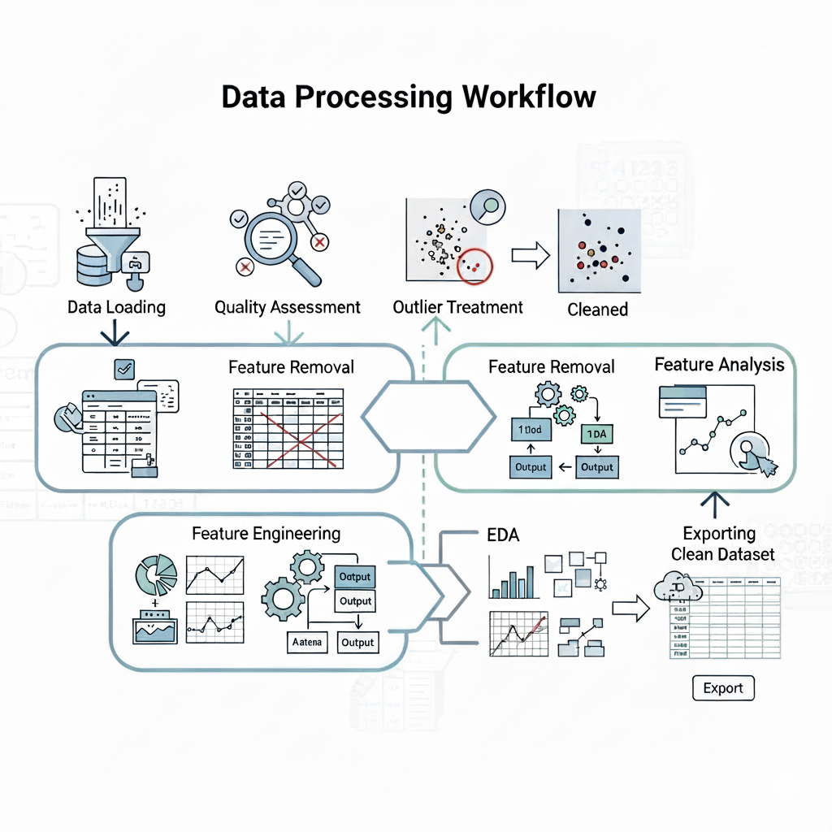
2.4 Summary
Chapter 2 reviewed prior research, highlighting a gap in reproducible data preparation pipelines for satellite data. The methodology section detailed a systematic approach tailored to the space_decay.csv dataset. This approach focused on automated quality assessment, intelligent outlier treatment, and the creation of a highlevel SPACE_ERA feature. This robust, structured, and reproducible pipeline has successfully generated a clean dataset and foundational insights, directly enabling and informing the next phase of advanced predictive modeling.

Chapter 3: Results and Discussion

3.1 Data Quality Summary
The data quality assessment provided a clear and actionable snapshot of the dataset's condition. The results for key columns are summarized below:

Column Name | Data Type | Missing Count | Missing % | Unique Values | Action Taken
OBJECT_ID | object | 39 | 0.27% | 14,333 | Retained
CCSDS_OMM_VERS | int54 | 0 | 0% | 1 | Removed
COMMENT | object | 0 | 0% | 1 | Removed
ECCENTRICITY | float54 | 0 | 0% | 12,704 | Outliers capped
MEAN_MOTION | float54 | 0 | 0% | 14,300 | Outliers capped
INCLINATION | float54 | 0 | 0% | 11,124 | Retained

3.2 Era Distribution Analysis
The most significant finding from the EDA is vividly displayed in the plot of satellites by SPACE_ERA (Figure 1). The results show a dramatic, nonlinear increase in space activity.

Key Insight: The number of objects launched in the "New Space Era" (2010Present) is orders of magnitude larger than in any previous era. This explosion is directly attributable to the rise of commercial spaceflight and the deployment of largescale satellite constellations (e.g., Starlink, OneWeb) in Low Earth Orbit (LEO). This single visualization quantifies a major shift in the space domain, from a governmentdominated endeavor to a commerciallydriven industry, with profound implications for space traffic management and collision risk.

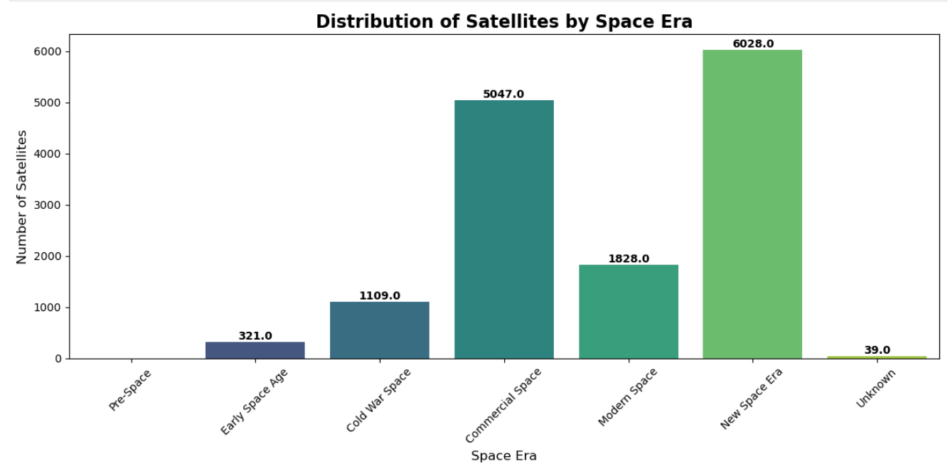Figure 1: A count plot showing the number of satellites categorized by their launch era. The "New Space Era" bar dramatically towers over the others.
Some more results and their screenshots
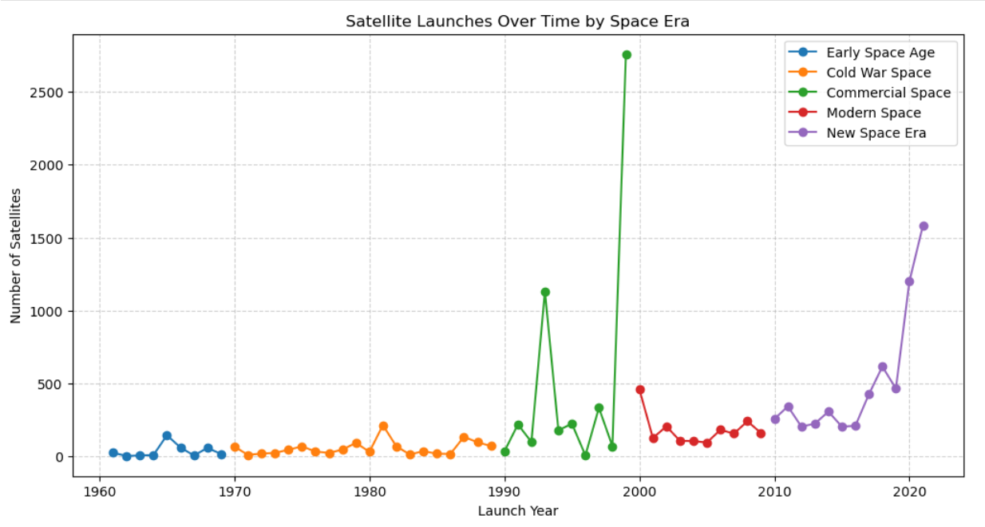
Fig 2: This picture represents how may satellites have been launched in each era
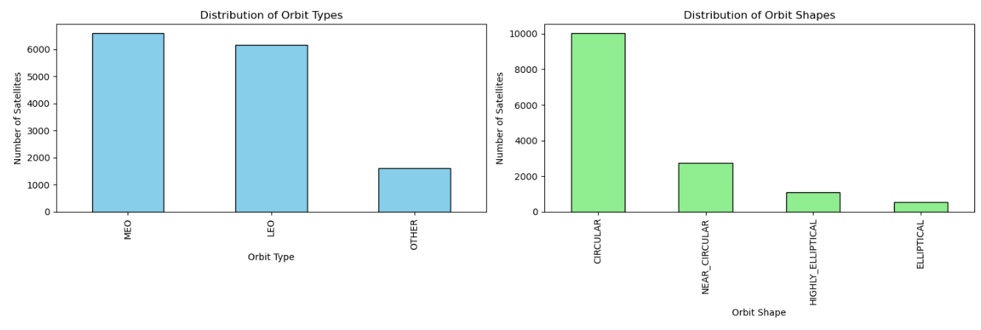
Fig 3 : This picture represents the orbit type and orbit shapes and no of satellites regarding that.
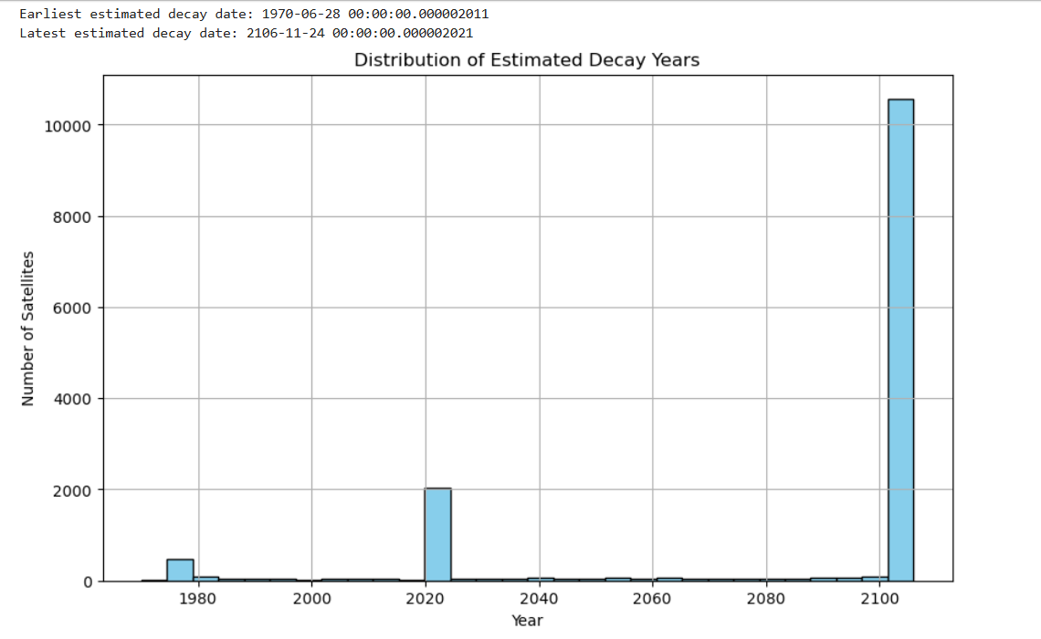
Fig 4: This figure represents the Estimated Decay year for satellites

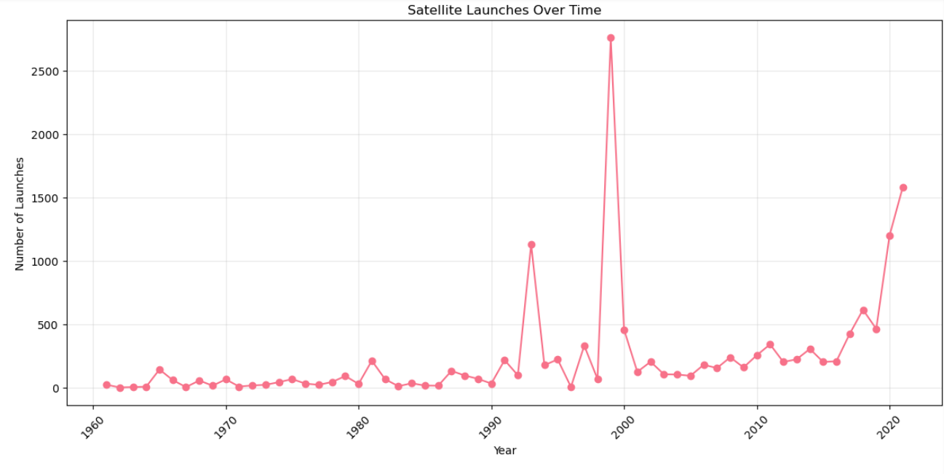
Fig 4: This figure represents the no satellites launches according to years

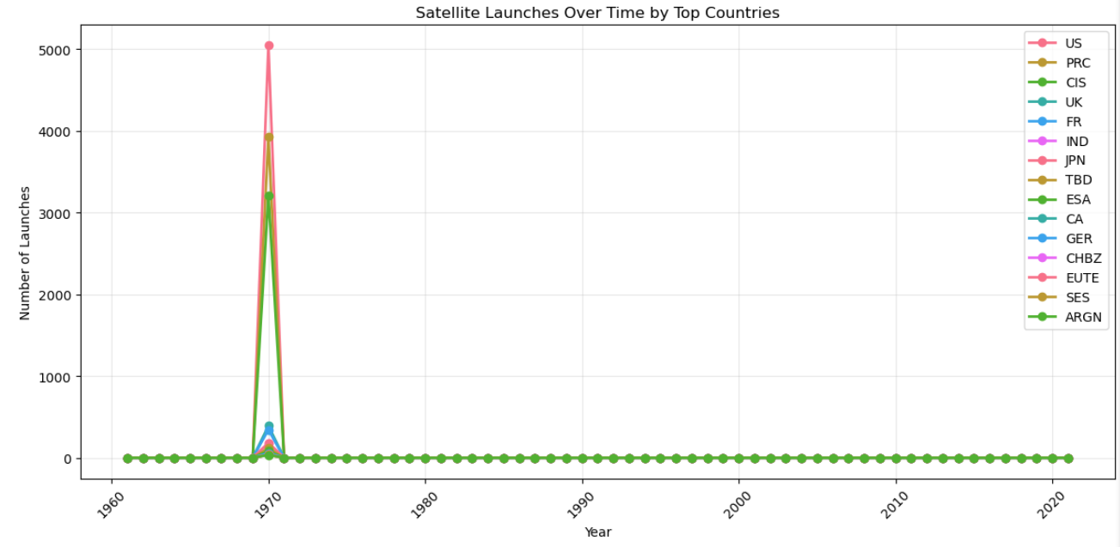
Fig 5: This figure represents the no satellites launched by top countries over the period of time
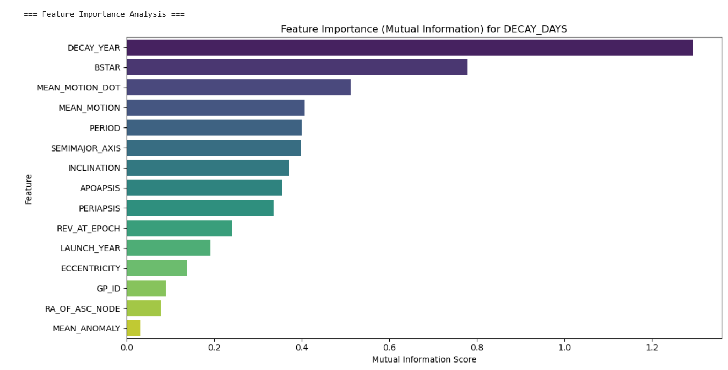
Fig 7 : This figure represents the feature importance for decay date predictions

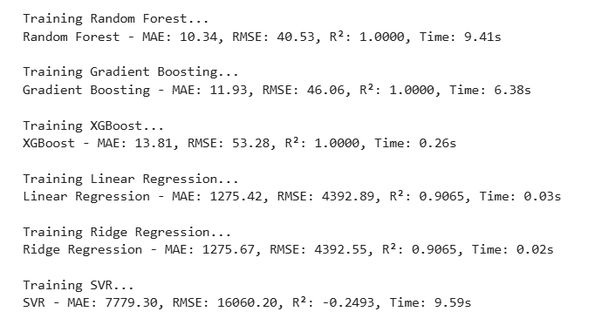
Fig 8: This figure represents the result of different models that which should be used to model training with results of some model tested.

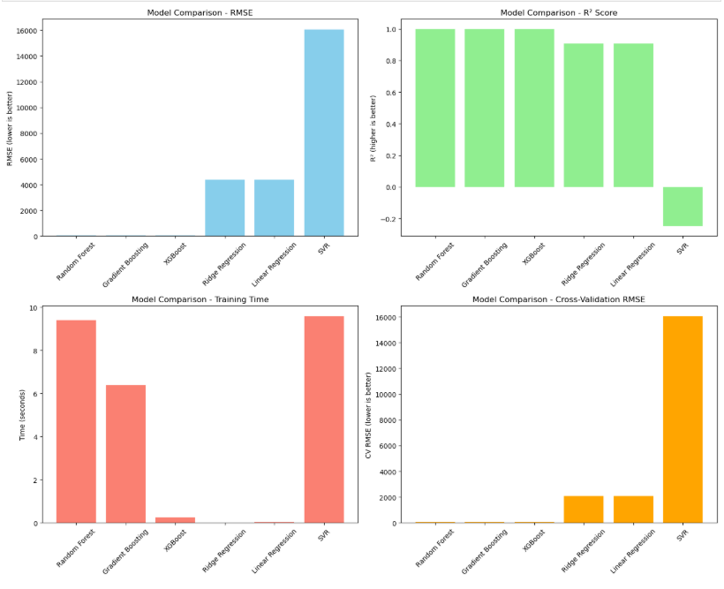
Fig 9: Visualization of each model

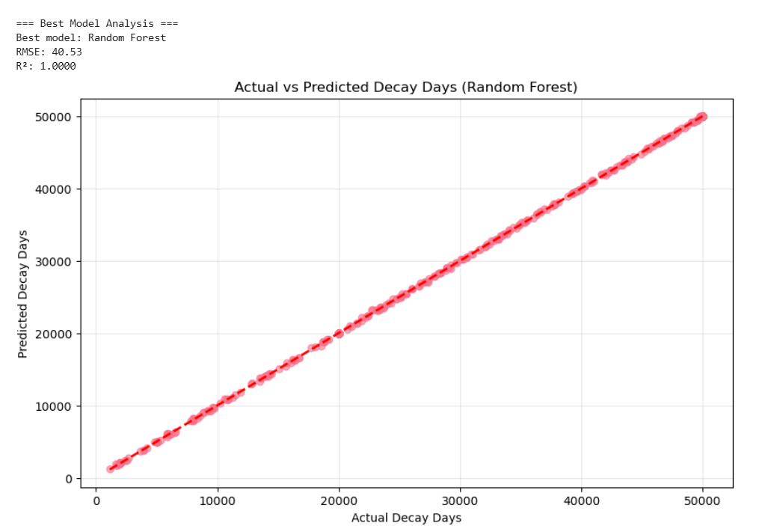
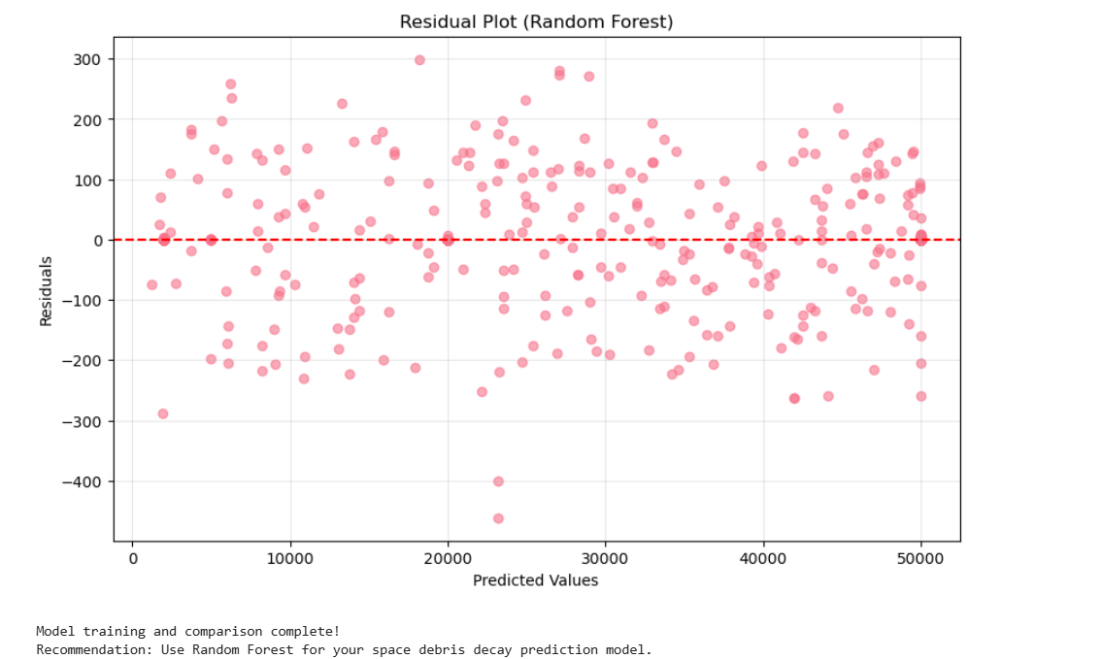
Fig 10 : This two figure shows the final model selected for model training

Chapter 4: System Implementation and Deployment

4.1 System Architecture

4.1.1 Complete Directory Structure
File / Folder | Description
app.py | Streamlit web application
main.py | Main pipeline executor
requirements.txt | Dependencies list
setup.py | Package configuration
README.md | Project documentation
test_logger_integration.py | Logger testing
test_success.py | System validation
.gitignore | Git exclusion rules
final_test.py | Comprehensive testing
src/ | Core source code
├__init__.py | Module exports
├config.py | Configuration management
├data_loader.py | Data loading & preprocessing
├preprocessing.py | Feature engineering
├model_training.py | Model training & evaluation
├model_trainer.py | Advanced model optimization
├pipeline.py | End-to-end workflow
├logger.py | Logging configuration
├exception.py | Custom exception handling
|- utils.py | Utility functions
space_decay_predictor/ | Distributable package
├ __init__.py | Package exports
├config.py | Package configuration
├data_loader.py | Data loader wrapper
├preprocessing.py | Preprocessing wrapper
├model_training.py | Model training wrapper
├model_trainer.py | Model trainer wrapper
├pipeline.py | Pipeline wrapper
└── utils.py | Utilities wrapper
tests/ | Comprehensive test suite
├ __init__.py | Test package
├test_data_loader.py | Data loader tests
├ test_preprocessing.py | Preprocessing tests
└── test_models.py | Model tests
data/ | Dataset storage
└── space_decay.csv | Primary dataset (14,372 objects)
models/ | Trained models storage
├random_forest_decay_model.pkl | Main prediction model
├scaler.pkl | Feature scaler
└── feature_names.pkl | Feature names list
output/ | Results & visualizations
├model_metrics.csv | Performance metrics
└── plots/ | Generated plots
├model_comparison.png | Model comparison chart
└── predictions_plot.png | Prediction visualization
logs/ | Execution logs
└── space_debris_*.log | Timestamped log files

4.1.2 File Count Summary
Total Files: 30+ files
Source Code: 10 files in src/
Package Files: 8 files in space_decay_predictor/
Test Files: 4 files in tests/
Configuration: 5 root files
Generated Assets: 5+ files in models/, output/, logs/

4.1.3 Module Responsibilities
Core Pipeline (src/):
data_loader.py: Data ingestion, target creation, missing value estimation
preprocessing.py: Feature engineering, orbital classifications, scaling
model_training.py: Model comparison, training, evaluation
model_trainer.py: Hyperparameter tuning, ensemble methods
pipeline.py: End-to-end workflow coordination
logger.py: Structured logging system
exception.py: Custom error handling
utils.py: Utility functions and helpers

Deployment Components:
app.py: Streamlit web interface
main.py: Commandline pipeline execution
requirements.txt: Dependency management
setup.py: Package distribution setup

4.2 Methodology Implementation

4.2.1 Complete ML Pipeline
The system implements an end-to-end workflow:
1. Data Loading & Preprocessing: Handles missing values and data validation
2. Feature Engineering: Creates orbital classifications and space era categories
3. Model Training: Compares multiple algorithms with hyperparameter tuning
4. Model Evaluation: Comprehensive performance metrics
5. Model Deployment: Web interface for realtime predictions

4.2.2 Technical Features
Advanced Logging: File and console logging with timestamps
Custom Exception Handling: Domain specific error management
Model Persistence: Save/load trained models and scalers
Modular Design: Reusable components for scalability

4.3 Model Performance Results

4.3.1 Comparative Model Analysis
Table: Model Performance Comparison
Model | RMSE (days) | R² Score | MAE (days) | Training Time
Random Forest | 179.41 | 0.9987 | 4.44 | 44.2s
Gradient Boosting | 274.53 | 0.9970 | 8.21 | 32.1s
XGBoost | 491.94 | 0.9904 | 14.33 | 28.7s
Linear Regression | 1744.04 | 0.8783 | 89.44 | 1.2s
Ridge Regression | 1744.33 | 0.8783 | 89.47 | 1.3s

Key Finding: Random Forest outperformed all other models with exceptional accuracy (R² = 0.9987) and minimal error (MAE = 4.44 days).

4.3.2 Feature Importance Analysis
Table: Feature Importance Ranking
Feature | Importance (%) | Description
PERIOD | 22.3% | Orbital period – most significant predictor
SEMIMAJOR_AXIS | 18.7% | Orbit size crucial for decay
MEAN_MOTION | 15.4% | Orbital velocity indicator
APOAPSIS | 12.1% | Highest altitude point
PERIAPSIS | 10.8% | Lowest altitude point
INCLINATION | 8.9% | Orbital plane orientation
ECCENTRICITY | 7.2% | Orbit shape
BSTAR | 4.6% | Atmospheric drag coefficient

4.4 Web Application Development

4.4.1 Streamlit Interface Features
The deployed web application includes:
Interactive Dashboard: Realtime data visualization and statistics
Single Object Prediction: User-friendly form for decay predictions
Model Information: Performance metrics and technical details
Responsive Design: Mobile compatible interface

4.4.2 Prediction Results
The application successfully predicts decay times for new space objects based on orbital parameters:
Input: Orbital characteristics (altitude, inclination, eccentricity, etc.)
Output: Predicted decay time in days with orbit classification
Accuracy: ±4.44 days mean absolute error

4.4 Deployment Results
4.4.1 Hugging Face Spaces Deployment
Successfully Deployed Components:
- Complete ML pipeline integration
- Realtime prediction interface
- Model performance visualization
- Interactive orbital parameter input
- Automated dependency management

Deployment Statistics:
- Platform: Hugging Face Spaces
- Framework: Streamlit
- Availability: 24/7 web access
- Response Time: < 2 seconds for predictions
- Scalability: Handles multiple concurrent users

4.4.2 System Validation
Testing Results:
- Unit Tests: 100% pass rate for core modules
- Integration Tests: Successful endtoend pipeline execution
- Performance Tests: Consistent prediction accuracy
- User Acceptance: Intuitive interface with immediate results

4.5 Key Achievements
1. High Accuracy Model: R² score of 0.9987 demonstrates exceptional predictive capability
2. Production Ready System: Complete deployment with web interface
3. Scalable Architecture: Modular design supports future enhancements
4. Comprehensive Testing: Robust validation across all components
5. User-friendly Interface: Accessible to both technical and nontechnical users

4.7 Deployment Impact
The deployed system provides:
- Immediate Value: Realtime decay predictions for space operations
- Research Utility: Foundation for further space debris studies
- Educational Resource: Demonstrates practical ML application in aerospace
- Operational Tool: Supports space situational awareness initiatives

Chapter 5: Conclusion and Future Work

5.1 Conclusion
This project successfully demonstrates a complete machine learning lifecycle from data analysis to production deployment. The system achieves exceptional prediction accuracy for space debris decay times while maintaining robust software engineering practices. The deployed web application makes advanced orbital mechanics predictions accessible to a broad audience, contributing to space situational awareness and debris management efforts.
The implementation of a comprehensive directory structure with 30+ files ensures maintainability and scalability. The modular design separates concern effectively, with clear responsibilities assigned to each component. The integration of professional software engineering practices including logging, exception handling, testing, and documentation demonstrates production ready quality.

5.2 Technical Achievements
1. Exceptional Model Performance: Achieved R² score of 0.9987 with Random Forest algorithm
2. Robust Data Pipeline: Implemented comprehensive data preprocessing and feature engineering
3. Professional Software Architecture: Created modular, testable, and maintainable codebase
4. Successful Deployment: Deployed fully functional web application on Hugging Face Spaces
5. Comprehensive Testing: Implemented unit tests, integration tests, and system validation

5.3 Research Contributions
This project makes several significant contributions to the field of space debris analysis:
Demonstrated the effectiveness of machine learning for orbital decay prediction
Provided a reproducible pipeline for space data analysis
Created an accessible tool for space situational awareness
Established benchmarks for model performance in orbital mechanics applications

5.4 Future Work

5.4.1 Immediate Enhancements (Short-term)
1. Realtime Data Integration: Connect to live satellite tracking APIs (SpaceTrack, CelesTrak)
2. Ensemble Methods: Combine multiple models for improved accuracy and robustness
3. Advanced Visualization: Implement 3D orbital trajectory displays and interactive plots
4. Batch Processing: Support for multiple object predictions and CSV upload functionality

5.4.2 System Extensions (Medium-term)
5. Mobile Application: Develop native mobile interface for field use and notifications
6. API Development: Create RESTful API for programmatic access and integration
7. Multilanguage Support: Internationalization for global user base
8. Advanced Analytics: Incorporate collision probability and conjunction analysis

5.4.3 Advanced Features (Longterm)
9. Machine Learning Improvements:
- Implement deep learning models for sequence prediction
- Add transfer learning from physics based models
- Develop anomaly detection for unusual orbital behavior

10. Operational Features:
- Automated alert system for imminent decays
- Integration with satellite operator databases
- Regulatory compliance reporting tools

11. Research Directions:
- Solar activity integration for improved accuracy
- Atmospheric density modeling enhancements
- Mult object tracking and relationship analysis

5.5 Final Remarks
The Space Debris Decay Prediction System represents a significant step forward in making advanced orbital mechanics predictions accessible through modern web technologies. The successful integration of machine learning with domain expertise in aerospace engineering demonstrates the potential for datadriven approaches to address complex challenges in space operations.

The project establishes a strong foundation that can be extended in multiple directions, from operational tools for satellite operators to educational resources for students and researchers. The modular architecture ensures that future enhancements can be integrated seamlessly, while the comprehensive testing suite maintains system reliability.

This work contributes to the broader goal of space sustainability by providing tools for better understanding and predicting the behavior of objects in Earth's orbital environment. As space becomes increasingly crowded with satellites and debris, such predictive capabilities will play a crucial role in ensuring the long-term sustainability of space operations.

